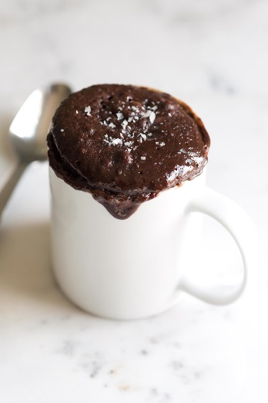
Microwave Brownie in a Cup
Author: Melissa @ No. 2 Pencil
Recipe type: Dessert
Prep time: 1 min
Total time: 1 min

Make a decadent homemade brownie in the microwave in just a few minutes.
Ingredients
- 2 tablespoons of butter
- 2 tablespoons of sugar
- 1 firmly packed tablespoon of light brown sugar
- ¼ teaspoon of pure vanilla extract
- Pinch of kosher salt
- 1 egg yolk
- 4 tablespoons of flour
- 1 tablespoon of Hershey’s unsweetened cocoa powder
- 2 heaping tablespoons of semi sweet chocolate chunks
Instructions
- Melt butter in microwave safe mug or ramekin. Butter should be melted, not boiling.
- Stir together butter, sugars, vanilla and salt.
- Stir in egg yolk. Do not use egg white! Save for a different recipe or discard.
- Add flour and cocoa powder and stir again until well combined.
- Finally, add chocolate chunks.
- Cook for about 45 seconds in microwave. Do not over cook. Microwave times may vary.

